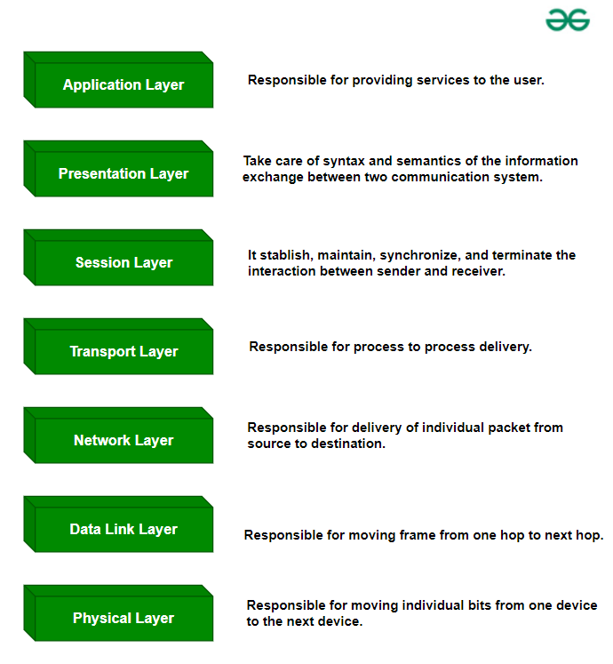

**Physical Layer – Layer 1**

* responsible for the actual physical connection between the devices
* information in the form of**bits.**
* specifies how the different, devices/nodes are arranged in a network i.e. bus, star, or mesh topology.
* defines how the data flows between the two connected devices. The various transmission modes possible are Simplex, half-duplex and full-duplex.
* *Hub, Repeater, Modem, and Cables are Physical Layer devices.*

**Data Link Layer (DLL) – Layer 2**

* make sure data transfer is error-free from one node to another, over the physical layer
* After creating frames, the Data link layer adds physical addresses (**MAC addresses**) in the header of each frame.
* Packet in the Data Link layer is referred to as Frame.
* Switch & Bridge are Data Link Layer devices.

**Network Layer – Layer 3**

* takes care of packet routing i.e. selection of the shortest path to transmit the packet, from the number of routes available.
* The sender & receiver’s [IP address](https://www.geeksforgeeks.org/what-is-an-ip-address)es are placed in the header by the network layer.
* Segment in the Network layer is referred to as Packet.
* Network layer is implemented by networking devices such as routers and switches.

**Transport Layer – Layer 4**

* The data in the transport layer is referred to as *Segments*
* responsible for the end-to-end delivery of the complete message
* The port number directs each segment to the correct application.
* Segment number helps in the reassembly of the segments correctly at the receiver.
* Device or Protocol Use : TCP, UDP NetBIOS, PPTP

**Services Provided by Transport Layer**

**1. Connection-Oriented Service:** It is a three-phase process that includes:

* Connection Establishment
* Data Transfer
* Termination/disconnection

In this type of transmission, the receiving device sends an acknowledgment, back to the source after a packet or group of packets is received. This type of transmission is reliable and secure.

**2. Connectionless service:** It is a one-phase process and includes Data Transfer. In this type of transmission, the receiver does not acknowledge receipt of a packet. This approach allows for much faster communication between devices. Connection-oriented service is more reliable than connectionless Service.

**Session Layer – Layer 5**

* This layer is responsible for the establishment of connection, maintenance of sessions, and authentication, and also ensures security.
* ***Device or Protocol Use :****NetBIOS, PPTP.*

**Presentation Layer – Layer 6**

* **Translation:** For example, [ASCII to EBCDIC](https://www.geeksforgeeks.org/difference-between-ascii-and-ebcdic).
* **Encryption/ Decryption:** Data encryption translates the data into another form or code. The encrypted data is known as the ciphertext and the decrypted data is known as plain text. A key value is used for encrypting as well as decrypting data.
* **Compression:** Reduces the number of bits that need to be transmitted on the network.
* **or Protocol Use:**  JPEG, MPEG, GIF.

**Application Layer – Layer 7**

***Device or Protocol Use :***[*SMTP*](https://www.geeksforgeeks.org/simple-mail-transfer-protocol-smtp)*.*

* **File Transfer Access and Management(FTAM):**This application allows a user to  
  access files in a remote host, retrieve files in a remote host, and manage or  
  control files from a remote computer.
* **Mail Services:**Provide email service.
* **Directory Services:** This application provides distributed database sources  
  and access for global information about various objects and services.

| **Layer No** | **Layer Name** | **Responsibility** | **Information Form (Data Unit)** | **Device or Protocol** |
| --- | --- | --- | --- | --- |
| **7** | [Application Layer](https://www.geeksforgeeks.org/open-systems-interconnection-model-osi/#application-layer-layer-7) | Helps in identifying the client and synchronizing communication. | Message | [SMTP](https://www.geeksforgeeks.org/simple-mail-transfer-protocol-smtp) |
| **6** | [Presentation Layer](https://www.geeksforgeeks.org/open-systems-interconnection-model-osi/#presentation-layer-layer-6) | Data from the application layer is extracted and manipulated in the required format for transmission. | Message | [JPEG](https://www.geeksforgeeks.org/jpeg-full-form), [MPEG](https://www.geeksforgeeks.org/mpeg-full-form), [GIF](https://www.geeksforgeeks.org/what-is-a-gif-file) |
| **5** | [Session Layer](https://www.geeksforgeeks.org/open-systems-interconnection-model-osi/#session-layer-layer-5) | Establishes Connection, Maintenance, Ensures Authentication and Ensures security. | Message (or encrypted message) | [Gateway](https://www.geeksforgeeks.org/what-is-circuit-level-gateway) |
| **4** | [Transport Layer](https://www.geeksforgeeks.org/open-systems-interconnection-model-osi/#transport-layer-layer-4) | Take Service from Network Layer and provide it to the Application Layer. | Segment | [Firewall](https://www.geeksforgeeks.org/introduction-of-firewall-in-computer-network) |
| **3** | [Network Layer](https://www.geeksforgeeks.org/open-systems-interconnection-model-osi/#network-layer-layer-3) | Transmission of data from one host to another, located in different networks. | Packet | [Router](https://www.geeksforgeeks.org/introduction-of-a-router) |
| **2** | [Data Link Layer](https://www.geeksforgeeks.org/open-systems-interconnection-model-osi/#data-link-layer-layer-2) | Node to Node Delivery of Message. | Frame | [Switch](https://www.geeksforgeeks.org/what-is-a-network-switch-and-how-does-it-work), [Bridge](https://www.geeksforgeeks.org/what-is-bridge-in-computer-network-types-uses-functions-differences) |
| **1** | [Physical Layer](https://www.geeksforgeeks.org/open-systems-interconnection-model-osi/#physical-layer-layer-1) | Establishing Physical Connections between Devices. | Bits | [Hub](https://www.geeksforgeeks.org/what-is-network-hub-and-how-it-works), [Repeater](https://www.geeksforgeeks.org/repeaters-in-computer-network), [Modem](https://www.geeksforgeeks.org/what-is-modem), Cables |

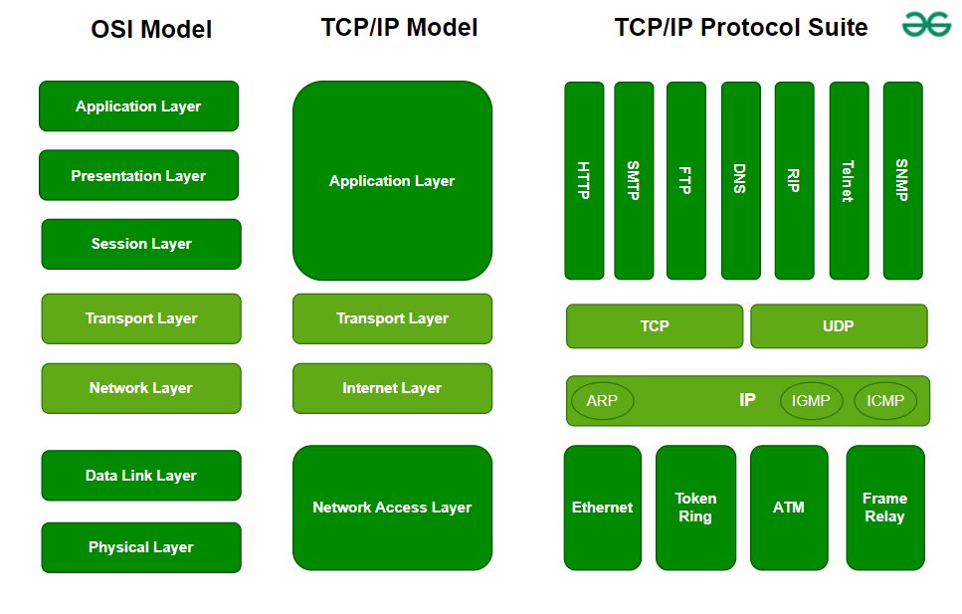**OSI vs TCP/IP Model**

* TCP/IP model consists of 4 layers but OSI model has 7 layers.**Layers 5,6,7 of the OSI model are combined into the Application Layer of TCP/IP model**and **OSI layers 1 and 2 are combined into Network Access Layers of TCP/IP protocol.**
* The TCP/IP model is older than the OSI model, hence it is a foundational protocol that defines how should data be transferred online.
* Compared to the OSI model, the TCP/IP model has less strict layer boundaries.
* All layers of the TCP/IP model are needed for data transmission but in the OSI model, some applications can skip certain layers. Only layers 1,2 and 3 of the OSI model are necessary for data transmission.

***Note:****The OSI model acts as a reference model and is not implemented on the Internet because of its late invention. The current model being used is the TCP/IP model.*

**Advantages of OSI Model**

The OSI Model defines the communication of a computing system into 7 different layers. Its advantages include:

* It divides network communication into 7 layers which makes it easier to understand and troubleshoot.
* It standardizes network communications, as each layer has fixed functions and protocols.
* Diagnosing network problems is easier with the **OSI model**.
* It is easier to improve with advancements as each layer can get updates separately.

**Disadvantages of OSI Model**

* **Complexity:** The OSI Model has seven layers, which can be complicated and hard to understand for beginners.
* **Not Practical:**In real-life networking, most systems use a simpler model called the Internet protocol suite (TCP/IP), so the OSI Model isn’t always directly applicable.
* **Slow Adoption:** When it was introduced, the OSI Model was not quickly adopted by the industry, which preferred the simpler and already-established TCP/IP model.
* **Overhead:** Each layer in the OSI Model adds its own set of rules and operations, which can make the process more time-consuming and less efficient.
* **Theoretical:** The OSI Model is more of a theoretical framework, meaning it’s great for understanding concepts but not always practical for implementation.

